Pre-Lab 8

Shiyu Wang

Pre 8.1)

1. What signal input is necessary to increment the counter by one?

Boolean “1” for positive.

1. What signal input is necessary for the counter to count down by one?

Boolean “0” for negative.

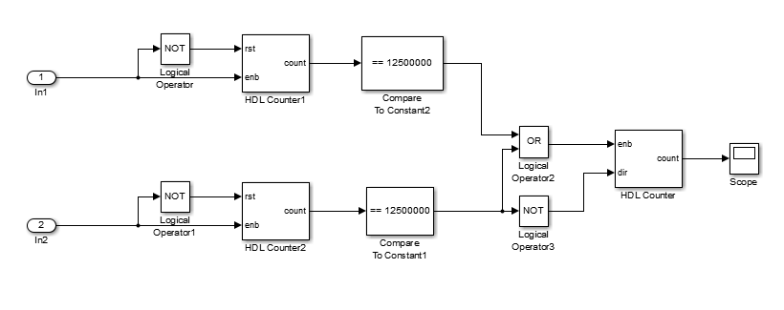

Pre 8.2)

The speed of the second counter is depended on “Count to value” of the count limitation. The higher the limitation is, the slower of the counter. The reset is used to reset the counter to 0 when the button is released.